**Few Shot Prompting 01: Conversation Manipulation**

In this blog , we will explore the concept of few-shot prompting using Langchain, focusing on manipulating conversation with large language models (LLMs). Before diving into the technical details, let's first understand what LLMs are and how we interact with them.Before getting into the details, let’s understand what are LLMs And how exactly we interact with LLMs.

Large Language Models (LLMs) are a subset of artificial intelligence (AI) focused on understanding, generating, and manipulating human language. Models like OpenAI’s GPT-4, are trained on vast datasets encompassing a broad spectrum of human knowledge, enabling them to perform tasks ranging from text generation and translation to question answering and more.

Now how do we interact with these models? A “prompt” is the input or instruction given to an LLM to elicit a desired response. “Prompt Engineering” involves designing these inputs to guide the model’s output effectively. It includes crafting questions, providing context, or setting specific instructions that help the LLM understand what kind of response is expected. Effective prompt engineering can significantly enhance the quality and relevance of the model’s output.

LLMs can be broadly categorized into text completion models and chat models:

•Text Completion Models: These models generate text to complete a given input. They are typically used for tasks where a single, continuous piece of text is needed, such as writing an essay or completing a sentence.

•Chat Models: These models are designed for interactive and dynamic conversations. They maintain context over multiple turns, making them suitable for applications like customer service bots, virtual assistants, and interactive storytelling.

Let’s consider Chat Models for our task. Chat model schema is composed of three parts:

System Message : Here we mention the role assigned to the AI

Human Message : The question we are asking

AI Message : A sample response of how we want AI to respond

Few-shot prompting is a technique where the model is given a few examples of the desired task within the prompt. This helps the model understand the task better and generate more accurate responses, even with limited explicit instructions

Now let’s get into the task, here the dataset I have considered is the book “The importance of being Earnest” .A comedic play written by Oscar Wilde that satirizes Victorian society’s social and conventional values. The story revolves around 2 friends with polar opposite personalities. The Protagonist of the story is Jack Worthing, a wealthy young gentleman, goes by the name Earnest , while the Antagonist is Algernon Moncrieff, close friend of Jack and a charming bachelor.

Let’s now get into the coding part. I am using Open AI’s GPT 3.5 here.

Let’s first do the necessary imports :

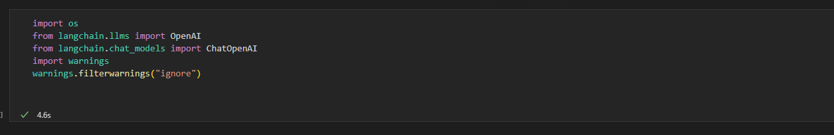

Next Step is to read the API key and call the OpenAI model

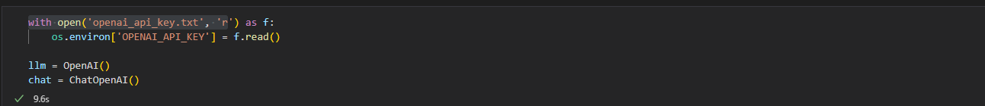

Let’s import the Chat Model Schema and then assign the sample query and response.

Here I have chose some conversation between Jack(Earnest) and his friend Algernon from the book, were Jack asks some questions and Algernon cracks some lame jokes.

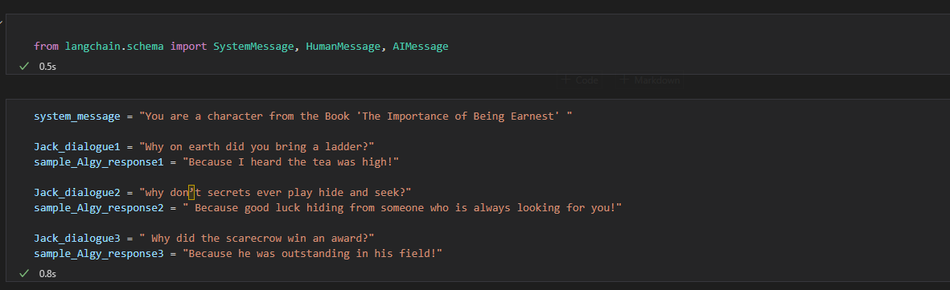

Now let’s pass a query to the model and see if it responds like Algernon with some lame joke.

